A picture containing clipart

Description generated with very high confidence

NodeJS Module 7

Hands-on 2

[**support@intellipaat.com**](mailto:support@intellipaat.com)

**+91-7022374614**

**US: 1-800-216-8930 (Toll Free)**

**NodeJS Module 7**

**Hands-on 2**

**CRUD Operations**

**Step 1**: Open the Mongo Shell

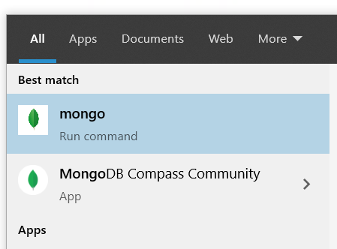

**Step 2**: Type the following code to create a collection

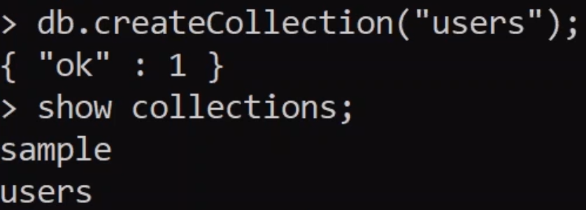

**Step 3**: Type the following code to insert data in the collection

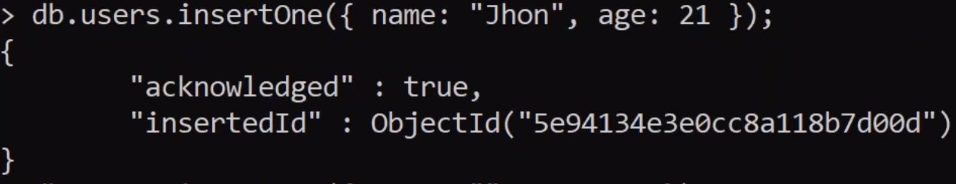

**Step 4**: Type the following code to read all the data in a collection



**Step 5**: Type the following code to update single record



**Step 6**: Type the following code to update many records:



**Step 7**: Type the following code to delete a records:

